**The Room 2.0**

You are a student and finding space in your room is a chore? In that case, you came at the right moment because a meeting has just been held in order to improve student’s life conditions.

Several companies were present at the university to show rooms more comfortable and friendly to the environment. The rooms have to be fitted with green feature and a building automation.

First, in terms of mobility, Habib was the one who attracted my attention with a removable bed including a bookcase, a closet and a cabinet. Furthermore, we can find shelves in it which enables the tenant to tidy more easily. So, this bed is the real future. It can be put in movement in order to leave space for a desk to work for example. This invention enables to win a lot of space in the room, which is the main problem in a student room. In regards of green feature, he decided to add solar panels on windows to save electricity when you use your appliances such as an air conditioner.

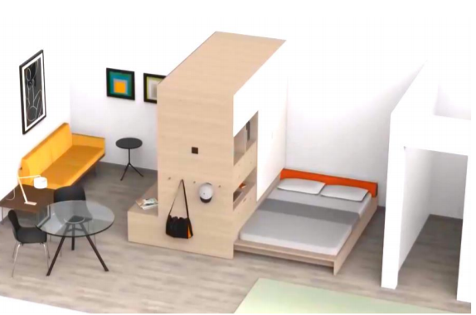

Then concerning the ecological and practical furniture, Vincent was the one to show the best project. All his furniture was adapted at the room with good size and with storage. But the real revolution concerns the temperature management.

Thanks to a tablet computer, you can control lighting and heating. Moreover, the room is fitted with LED bulb to save more energy.

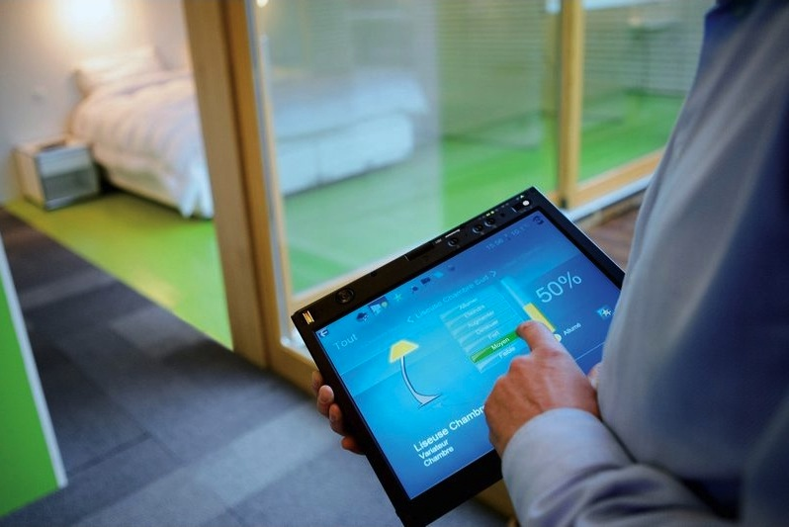

Even more, some rooms presented by other companies were totally ecological because they have wall papering, painting and carpeting made of ecological products.

The selected project is not known yet but whatever the decision, you will love your new life in this room 2.0.

Guilpain Léo